Cyber Data Catalog for Splunk — Whitepaper
Oct 28, 2026 · @Jeremy

Summary
The Cyber Data Catalog is a Splunk app that keeps one record of every data source a Splunk stack ingests, compares it with what is actually arriving, and shows which searches and dashboards depend on each source. It runs entirely inside Splunk Cloud: 64 scheduled searches, 28 KV Store tables and 16 dashboards, with no external services.
It answers four questions that usually take a spreadsheet and a week of searching:
- What data do we have, and who owns it? One catalog row per tenant and sourcetype, with tier, owners, contract and retention.
- Is it arriving, and is it any good? Silence, volume, latency, parsing errors and CIM field coverage, checked against each dataset's own baseline.
- What breaks if it stops or changes? A dependency graph from every saved search, correlation search and dashboard to the data it reads.
- What is missing? Data arriving with no catalog record or contract, contracts with no data, and required telemetry a tenant doesn't send.
It was built for a security (Splunk ES) estate, but most of it is generic Splunk operations tooling. The dependency graph, data health, ingestion quality, infrastructure monitoring and cost attribution work on any Splunk Cloud stack once a few macros are changed; the section on repurposing covers what to change.
Current version: 0.5.6, in the JeremyLance/cyber_data_catalog GitHub repository.

How it works
The app has three layers: scheduled searches read what Splunk already has, write the results into KV Store tables, and dashboards and alerts read those tables.
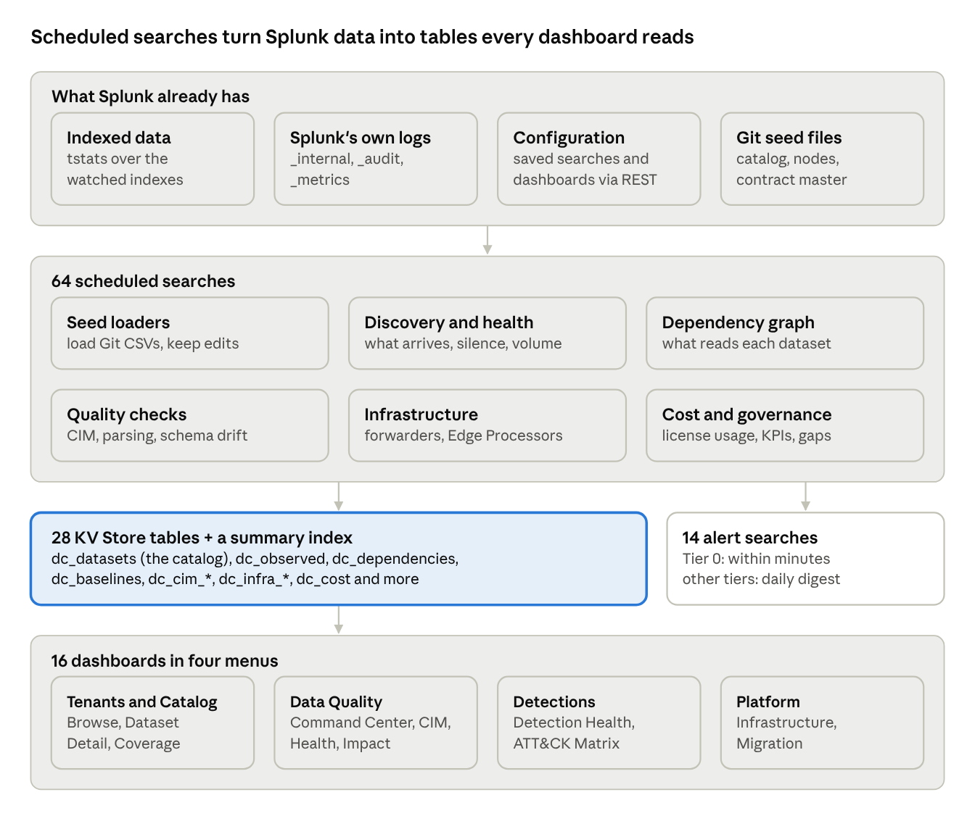
data flow · 4 sources, 64 searches, 28 tables, 16 dashboards
The catalog table, dc_datasets, is the hub: nearly every other table and page joins to it on dataset_id, which is the owner plus the sourcetype (for example uhgid-000111|ActiveDirectory). Human knowledge (owners, tiers, contracts) enters through CSV seed files kept in Git; everything else is discovered. Seed loaders merge rather than overwrite, so edits made in Splunk survive a re-run.
Two keys tie the data together:
- Dataset: owner + sourcetype. The logical stream that detections and reports consume, with its tier, owners and contract.
- Feed: owner + sourcetype + environment. The physical path it arrives by. While data is migrating between Splunk stacks, one dataset has several feeds, which is how the app gates a cutover.

Saved searches and the dashboards they support
Dashboards almost never query raw data. Scheduled searches write results into KV Store tables, and the dashboards read those tables, so pages load in seconds and the expensive work runs off-peak. The table groups the 64 searches by job; IDs are the DC - NN prefixes in Settings → Searches, reports, and alerts.
Group | Searches | What they do | Writes to | Dashboards that read it | Schedule
Seed loaders | DC-00, 00b, 00d, 38b | Load Git-managed CSV seeds into the KV Store without overwriting values people have edited | dc_datasets, dc_feeds, dc_infra_nodes, dc_sourcetype_rejections | Every catalog page; Infrastructure; Reject Sourcetype; Command Center | Daily 05:00–05:20
Catalog integrity | DC-00c | Alerts if catalog records lose identity fields or seed rows go missing | (alert) | — | Daily
Discovery | DC-01 (or DC-07 when dual-homing) | Records every index + sourcetype actually arriving, with last-seen time and 24h volume | dc_observed | Catalog Browse, Data Health, Impact Analysis, Migration and Pipeline, Command Center | Hourly
Reconciliation and shadow data | DC-02, 03, 38; DC-37 (paused) | Declared vs observed; classifies uncataloged data as malformed, rejected, contract-matched or novel; dedupes the contract master | Summary index; dc_shadow_classification; dc_contract_master | Data Health (trend), Catalog Browse, Command Center, Reject Sourcetype | Hourly to every 2h
Baselines and data health alerts | DC-04, 05, 06, 08, 09, 14 | Median + MAD volume baselines; silence and volume alerts by tier; pipeline-wide outage correlation; dual-home divergence; change-window audit | dc_baselines | Catalog Browse (health column), Data Health | Every 5 min to daily
Knowledge objects and dependency graph | DC-10, 11, 12, 13, 40 | Harvests every saved search and dashboard over REST, parses the SPL for index, sourcetype, data model, lookup and macro references, and counts real usage from _audit | dc_knowledge_objects, dc_dependencies | Impact Analysis, Dataset Detail, Data Health (blast radius), CIM Normalization, Coverage and Lifecycle | Nightly
Tiering | DC-20, 21 | Proposes each dataset's tier from the most critical content that consumes it, with a floor for named source types | dc_datasets (proposed_tier) | Catalog Browse | Nightly
Schema | DC-29 (manual), 30, 31 | Seeds a field schema from live data, then flags new, missing and retyped fields and field-list changes | dc_schema_fields, dc_observed | Dataset Detail, Impact Analysis | Daily
CIM normalization | DC-32, 33, 34, 101 | Data model capture rate, required-field coverage, tag coverage, and a weighted field-coverage score across 10 data models | dc_cim_compliance, dc_cim_coverage_scorecard | CIM Normalization, CIM Coverage Command Center | Daily; DC-101 every 4h
Pipeline quality | DC-35 | Index lag p50/p95, timestamp, truncation and line-breaking errors per sourcetype | dc_pipeline_quality | Migration and Pipeline | Every 2h
Index standard | DC-15, 16, 17, 36 | Data in the wrong index family, index names off the naming standard, unused families, malformed sourcetypes | dc_index_conformance | Index Standard | Nightly; DC-17 weekly
Detection health | DC-41, 42, 43, 62, 63 | Run/skip/fire history per detection, silent detections with healthy data, a confidence score, and ATT&CK technique coverage | dc_detection_health, dc_attack_mapping, dc_attack_coverage | Detection Health | Daily; DC-42 weekly
Requirements | DC-60, 61 | Which tenants lack telemetry the federated model requires | dc_requirement_coverage | Coverage, Cost and Lifecycle | Daily; DC-61 weekly
Cost | DC-72, 71, 73, 74 (DC-70 retired) | License usage per dataset and index family, savings categories, bytes-per-event baselines, silent format changes | dc_cost, dc_volume_baselines | Coverage, Cost and Lifecycle; Index Standard | Daily; DC-71 weekly
Governance and offboarding | DC-50, 80, 81 | Weekly coverage KPIs; orphaned content, zombie ingest, unowned data; per-tenant offboarding readiness | Summary index (DC-50); reports | — (email or scheduled report) | Daily or weekly
Infrastructure | DC-00e, 90–99b | Heavy forwarder and Edge Processor registry, heartbeat, queues, throughput baselines, datasets behind each node, discovery of unregistered nodes and universal forwarders | dc_infra_nodes, dc_infra_observed, dc_infra_baselines, dc_infra_candidates, dc_uf_nodes | Infrastructure, Promote Candidate | Every 5 min to daily
Searches that alert rather than feed a page: DC-00c, 03, 05, 06, 08, 14, 30, 42, 61, 74, 80, 93, 94, 96. These are where the app notifies people. Data and node outages are split by tier: DC-05 and DC-93 fire within minutes for Tier 0, while DC-06 and DC-94 send a daily digest for everything else.
Pages that query live instead of reading tables: Ingestion Quality (_internal), MITRE Matrix (REST), the live mode and reconciliation tab of the Command Center (tstats), and the 30-day volume chart on Dataset Detail. They are the slowest pages and the first to optimize if load becomes an issue.

Key dashboards
Six dashboards carry most of the value for a Splunk operations team; the other ten serve security-specific audiences or are forms. The app menu groups them as Tenants and Catalog, Data Quality, Detections, and Platform.

Catalog Browse (home page)
- Purpose: the front door. Every tenant × index × sourcetype the app knows about, with tier, owner, health and contract status.
- For: everyone; Splunk admins and auditors most.
- Shows: catalog size and owner coverage; contracts the SIEM team has completed, with monthly and per-tenant trends; a catalog table with a health flag (OK, DATA_DOWN, VOLUME_LOW, NEVER_SEEN) that drills into Dataset Detail; uncataloged "shadow" data and malformed sourcetypes to triage.
- Filters: tenant, domain, tier and sourcetype, applied to every panel.
- Fed by: DC-00, 01, 04, 20/21, 38 and the contract master.

Data Health and SLA
- Purpose: what is broken right now, ranked by what it breaks downstream rather than alphabetically.
- For: Splunk admins and on-call.
- Shows: Tier 0 breaches (war-room criteria), health by tier, a 24-hour reconciliation trend, and outages ranked by how many Tier 0 objects, detections and dashboards depend on the dataset.
- Fed by: DC-00, 01, 02, 04, 10–13; refreshes every 5 minutes.

Impact Analysis
- Purpose: run before approving a change. Pick a sourcetype and see every saved search, correlation search and dashboard that reads it, which tenants send it, and its contracted schema.
- For: Splunk admins planning props, transforms, index or retention changes; detection engineers.
- Fed by: DC-10–13 (the dependency graph), DC-29, DC-01.

CIM Coverage Command Center
- Purpose: the SIEM validation team's quality gate. Built from four tabs:
  - Sourcetype reconciliation: every sourcetype a tenant sends or has a contract for, flagged as malformed, rejected, uncontracted, contracted-but-silent, uncataloged or poorly normalized, with one action per row.
  - SIEM contracts and CDE: every contract, its CDE approval status and how long it has waited.
  - CIM field coverage: a 0–100 score per sourcetype per data model, from the last DC-101 run or live.
  - How to read this: what each column, score and flag means.
- For: SIEM validation, CDE, auditors.
- Fed by: DC-101, DC-38b, the contract master, live tstats.

Infrastructure (HF and Edge Processor)
- Purpose: the pipes, not the data. A dead heavy forwarder or Edge Processor takes every dataset behind it dark at once; this page catches that before per-dataset alerts cascade.
- For: Splunk platform admins.
- Shows: Tier 0 node breaches (10-minute silence budget), health by node type, nodes up but with throughput collapsed against baseline, full inventory, unowned nodes, and auto-discovered nodes awaiting review (drills into Promote Candidate).
- Fed by: DC-00d, 00e, 90–98.

Ingestion Quality
- Purpose: parsing failures that make data look present while events or fields are wrong.
- For: Splunk admins owning props and transforms.
- Shows: line-breaking, timestamp and truncation warnings over time, by sourcetype (with the tenants that send it) and by host, plus indexes with sourcetype sprawl.
- Fed by: live _internal searches; DC-35 tracks the same signals on a schedule.

The other dashboards
Dashboard | Purpose | Main audience
Dataset Detail | One dataset's catalog record, service agreement, 30-day volume, consumers and schema; drill-down target | Everyone
Migration and Pipeline | Feeds by environment, dual-home divergence (cutover gate), pipeline outages, change windows, pipeline hygiene | Splunk admins during migrations
Index Standard | Data in the wrong index family, nonconforming index names, unused families, cost by family | Splunk admins
Coverage, Cost and Lifecycle | Required-telemetry gaps by tenant, consolidation savings, offboarding readiness, cost by dataset | Leadership, auditors
CIM Normalization | CIM capture rate by tenant and data model; normalization gaps that blind detections | CDE, SOC
Detection Health | Detection confidence by tier, silent and skipped detections, ATT&CK techniques at risk | Detection engineering, SOC
MITRE ATT&CK Matrix | Technique-by-tactic coverage from production correlation searches | SOC, threat hunting
Reject Sourcetype, Promote Candidate, Setup | Forms that write a rejection, register a discovered node, or store the GitHub token | Splunk admins

Repurposing for non-security Splunk stacks
About two-thirds of the app is generic Splunk operations tooling and runs on an application or IT stack once five macros and two seed files are changed. The security-specific third (detections, ATT&CK, CIM and the SIEM contract process) can be disabled without affecting the rest.

What the security terms map to
In this app | On an application or IT stack
Tenant / AE (UHGID) | Application, team, business unit or customer
Dataset (tenant | sourcetype) | The same: one owner's stream of one sourcetype
Tier 0–3 | Service criticality (for example P1–P4)
SIEM contract | Onboarding request or data agreement
CDE approval | Data owner or architecture sign-off
Correlation searches | Alerts, reports and ITSI KPI searches

Keep, adapt or drop
Feature | Searches | Status on a non-security stack
Dependency graph and Impact Analysis | DC-10–13, 40 | Keep as is. It reads every saved search and dashboard on the stack, whatever they do
Data health, baselines, silence alerts | DC-01, 02, 04–06, 14 | Keep; retune the silence budget per tier
Ingestion Quality and pipeline hygiene | DC-35 | Keep as is
Infrastructure (HF, Edge Processor, UF) | DC-00d, 00e, 90–99b | Keep; load your own node inventory
Cost and volume | DC-72, 71, 73, 74 | Keep; set your $/GB rate
Schema drift | DC-29–31 | Keep for structured application logs
Shadow data detection | DC-03, 38 | Keep; contract matching optional
Index naming standard | DC-15–17, 36 | Adapt to your naming convention or disable
Required-telemetry register | DC-60, 61 | Adapt: list what each application must log in the requirement map seed
Governance and offboarding | DC-50, 80, 81 | Keep
CIM pages and scoring | DC-32–34, 101 | Drop unless the stack uses CIM data models
Detection health and ATT&CK | DC-41–43, 62, 63; MITRE Matrix | Drop
SIEM contracts, CDE, GitHub sync | DC-37, 39; contracts tab | Drop or adapt to your onboarding process

The settings that make it security-specific
All of them are macros in default/macros.conf, so changing them never touches the searches:
- dc_scope_indexes: which indexes the app watches. Today (index=sec_*); for example (index=app_* OR index=infra_*).
- dc_key: how the owner is derived from an index name. Today it extracts uhgid-NNNNNN from sec_<domain>_uhgid-NNNNNN. Rewrite the regex for your naming convention, or replace it with a lookup from index to owner if names don't encode one. This is the most important change: every dataset ID is built from it.
- dc_index_family: the index naming standard. Rewrite or disable Index Standard.
- dc_default_silence and dc_tier_num: tier names and how long each tier may go silent before alerting.
- dc_cost_per_gb, dc_local_environment, dc_queue_capacity_kb: contracted rate, environment label for this stack, forwarder queue size.

Steps to stand it up on another stack
- Copy the repo and change the app ID, label and version in default/app.conf.
- Rename the KV Store collections if the copy will share a search head with this app. metadata/default.meta exports collections, transforms and views system-wide, so two apps defining dc_datasets would collide. On a separate stack this isn't needed.
- Edit the macros above.
- Bootstrap the catalog from what is already flowing. Enable DC-01 for a day, then export dc_observed as a starting dc_datasets_seed.csv and fill in owners and tiers. This is faster than writing the seed by hand.
- Load the infrastructure inventory into dc_infra_nodes_seed.csv, or let DC-91 and DC-98 discover nodes and promote them through the form.
- Disable the dropped searches (set disabled = 1) and remove their dashboards from default/data/ui/nav/default.xml.
- Create the summary_datacatalog index in the Splunk Cloud admin console.
- Validate and install. Run Splunk AppInspect with the Cloud tags, then install as a private app.
- Run the load order in the next section.

Running across several stacks
Each stack runs its own copy with dc_local_environment set to that stack's name. Feeds then carry the environment in their key, and DC-07 and DC-08 can compare the same dataset across stacks, the same way they gate migration cutovers today. For one combined view, use federated search from a central search head or have each stack collect its summaries into a shared index.

Deploying and running it
The app installs as a private app on Splunk Cloud and needs no add-ons, though the CIM features need the Splunk Common Information Model add-on and accelerated data models.

Requirements
- KV Store enabled on the search head.
- A role that can run | rest against saved/searches and data/ui/views (for the dependency graph).
- Read access to _internal (scheduler, parsing warnings, license usage, forwarder metrics), _audit (search usage) and _metrics (Edge Processor heartbeat).
- A summary_datacatalog index, created in the Splunk Cloud admin console.
- Python 3.9 or 3.13 for the GitHub sync input and setup handler; the app declares both.

Load order on a new stack
- DC-00: creates and fills the catalog. Twenty-plus searches read it, so nothing else works until it has run.
- DC-00b, 00d, 38b: load the feed, infrastructure and rejection seeds.
- DC-00c: the integrity check, before any other search writes to the catalog.
- DC-01, 02, 03: discovery and reconciliation. Check the results.
- DC-10 to 14: the dependency graph, then DC-20 and 21 for tier proposals.
- The rest, by group: schema and CIM (30–35, 101), detections (41–43, 62, 63), requirements (60, 61), cost (71–74), offboarding (80, 81), infrastructure (90–99b).
Seed loaders merge rather than replace: a re-run adds new seed rows but never overwrites an owner, tier or status someone has set in Splunk. Commit seed changes to Git and re-run the loader.

Search load
Frequency | Searches
Every 5 minutes | 3 (Tier 0 data and node outages, Edge Processor heartbeat)
Every 10 minutes | 2 (pipeline outage correlation, forwarder heartbeat)
Hourly | 5
Every 2–4 hours | 4
Daily, mostly 01:00–08:00 | 40
Weekly | 6
Manual or disabled | 4
Most frequent searches read KV Store tables or tstats and finish in seconds. The heaviest are the nightly ones that use map (DC-29, 30, 31, 33), the 30-day license usage scans (DC-72, 73), and the CIM scorecard (DC-101, 61 tstats calls every 4 hours). Check those in the Monitoring Console's scheduler activity view during the first week.

Updating the app
The Git repository is the source of truth. Edit seeds and searches there, run AppInspect, and install the new package. Installing can replace lookup files on the search head with the packaged copies, so commit any CSV edited in Splunk (such as the contract master) back to the repo before each deploy.

Current limits and roadmap
The app is in active use and changing weekly; these are the known gaps as of version 0.5.6.

Known limits
- No Tier 0 datasets yet. CDE assigned Tiers 1–4 and Tier 5 means "no response yet". DC-21 proposes Tier 0 for domain controller, EDR, NDR and privileged-access sources for review, so Tier 0 alerting (DC-05) has nothing to fire on until those are ratified.
- Service agreements are empty. The dc_contracts table (expected volume, silence budget, SLA, notification channel) has no form or loader, so health checks fall back to tier defaults: 30 minutes for Tier 0 down to 3 days.
- Schema contracts are unreviewed. DC-29 seeded fields for 15 sourcetypes, all marked for review and with no CIM mapping, so CIM required-field coverage (DC-33) returns nothing yet.
- Detection confidence leaves out BAS until a breach-and-attack-simulation program reports results.
- The contract master is maintained by hand while the Splunk–GitHub runners are disabled; the GitHub sync ships paused.
- DC-01 and DC-07 are both enabled and write the same table. Only one should run: DC-07 once any feed is dual-homed, DC-01 otherwise.
- The dependency graph doesn't expand macros. A search that reaches data only through a macro is recorded as a low-confidence edge.
- Edge Processors are linked to datasets only through events carrying their own hostname, which undercounts what sits behind them.

Roadmap
- Tenant and Sourcetype views in Dashboard Studio: one page per tenant (datasets, health, CIM, requirements, detections, infrastructure, cost) and one per sourcetype (tenants, consumers, schema, ATT&CK), with tabs and shared filters.
- A loader or form for service agreements, so silence and volume thresholds come from agreed values instead of tier defaults.
- MLTK-based baselines: fit expected volume by hour of week, so quiet weekends stop looking like outages, and cluster uncataloged sourcetype names so near-duplicates are triaged together.
- Split DC-101 into one search per data model, so a timeout loses one domain instead of silently producing a partial scorecard.
- MITRE Matrix from the nightly ATT&CK mapping (DC-63) instead of a live REST call on every page load.
- Resume the GitHub contract sync once the runners are back, and backfill CDE approvals as they arrive.

